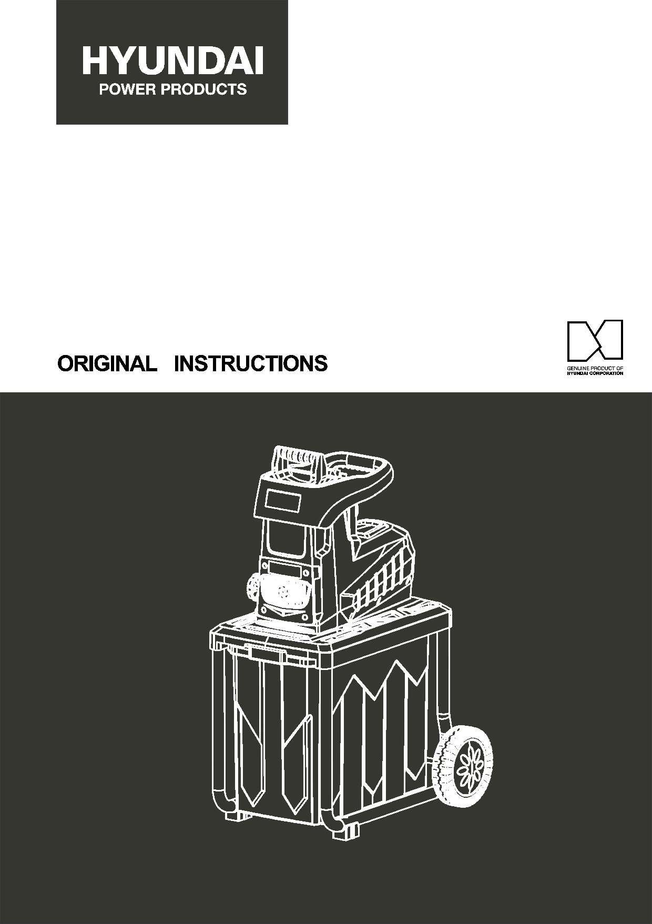

Electric plant shredder

HBVES2801

Warning: read this manual before using this maCHINE!

Contents
1. IMPORTANT safety INFORMATION 3
2. WARNING SYMBOLS 12
3.
Machine overview 13
4. Technical data 14
5. Assembling 14
6. Operating instruction 17
7. MAINTENANCE AND STORAGE..............................................................................................19
8. EC declaration of conformity 20
9. WARRANTY 21
10. PRODUCT FAILURE 22
11. WARRANTY EXCLUSIONS 23

1. IMPORTANT safety INFORMATION

READ CAREFULLY BEFORE USE

KEEP FOR FUTURE REFERENCE

Safe operating practices

Training
Become familiar with the owner’s manual before attempting to operate this equipment.

Preparation
- Do not allow children to operate this equipment;
- Do not operate this equipment in the vicinity of bystanders;
- Do not connect a damaged cord to the supply or touch a damaged cord before it is disconnected from supply. A damaged cord can lead to be contacted with live parts.
- Wear ear protection and safety glasses at all times while operating the machine;
- Avoid wearing clothing that is loose fitting or that has hanging cords or ties;
- Only operate the machine in open space (e.g. not close to a wall or other fixed object) and on a firm, level surface.
- Do not operate the machine on a paved or gravel surface where ejected material could cause injury;
- Before starting the machine, check that all screws, nuts, bolts, and other fasteners are properly secured and that guards and screens are in place. Replace damaged or unreadable labels;

Operation
- Before starting the machine, look into the feeding chamber to make certain that it is empty;
- Keep your face and body away from the feed intake opening;
- Do not allow hands or any other part of the body or clothing inside the feeding chamber, discharge chute, or near any moving part;
- Keep proper balance and footing at all times. Do not overreach. Never stand at a higher level than the base of the machine when feeding material into it;
- Always stand clear of the discharge zone when operating this machines;
- When feeding material into the machine be extremely careful that pieces of metal, rocks, bottles, cans or other foreign objects are not included;
- If the cutting mechanism strikes any foreign objects or if the machine should start making any unusual noise or vibration, shut off the power source and allow the machine to stop. Disconnect from supply and take the following steps:
Inspect for damage;
Check for and tighten any loose parts;
Have any damaged parts replaced or repaired with parts having equivalent specifications.
- Do not allow processed material to build up in the discharge zone; this may prevent proper discharge and can result in kickback of material through the feed intake opening;
- If the machine becomes clogged, shut-off the power source and disconnect from supply before clearing debris. Keep the power source clear of debris and other accumulations to prevent damage to the powered source or possible fire. Remember that operating the starting mechanism on engine powered machines will still cause the cutting means to move;
- Keep all guards and deflectors in place and in good working condition;
- Do not transport this machine while the power source is running;
- Shut off the power source and disconnect from supply whenever you leave the work area;
- Do not tilt the machine while the power source is running.
- To keep extension cords away from the shredding means. The shredding means can cause damage to the cords and lead to contact with live parts.
- If the supply cord is damaged, it must be replaced by the manufacturer, its service agent or similarly qualified persons in order to avoid a hazard.
- This appliance is not intended for use by persons (including children) with reduced physical, sensory or mental capabilities, or lack of experience and knowledge. Children should be supervised to ensure that they do not play with the appliance. Local regulations may restrict the age of the operator.
- Never operate the machine with defective guards or shields, or without safety devices, or if the cord is damaged or worn.
- Avoid using the machine in bad weather conditions especially when there is a risk of lightning.

Maintenance and storage
- When the machine is stopped for servicing, inspection, or storage, or to change an accessory, shut off the power source, disconnect from supply, make sure that all moving parts have come to a complete stop and, where a key is fitted remove the key. Allow the machine to cool before making any inspections, adjustments, etc.
- Always allow the machine to cool before storing;
- When servicing the cutting means be aware that, even though the power source will not start due to the interlock feature of the guard, the cutting means can still be moved by a manual starting mechanism.
- Keep the motor cooling vents clean of debris and other accumulations to prevent damage to the motor or possible fire.
- If an extension cord is used it shall not be of lighter grade than the supply cord already fitted to the appliance.
- Check the supply and any extension cord regularly for damage or signs of ageing. Do not use the appliance, if the cords are damaged.
- Never attempt to override the interlock feature of the guarding.

SAFETY ADVICE & INSTRUCTIONS
WARNING! When using electric garden tools basic safety precautions, should always be followed to reduce the risk of fire, electric shock and personal injury.

IMPORTANT-Safety, Health and Environment
Safe use of our power tool is only possible after the following safety and operating instructions have been fully read and observed.

Read all these instructions before operating this product and keep these instructions for future reference.

Follow the checklist below, before attempting to use the machine.
- The sheathing of the flex in the plug or socket is securely gripped under the cord grip.
- There is no damage to the sheath of the extension lead.
- The cable is run out safely to avoid damage or accidental tripping.
- The lead is fully unwound from the reel to avoid overheating.
Attention
The electrical AC MAINS SUPPLY may experience voltage drops when starting this equipment. This can influence other equipment (e.g. blinking of a lights). If the AC MAINS SUPPLY impedance Zmax is less than 0.40 0HM at 50Hz, such disturbances are not expected. If necessary, you may contact your local supply authority for further information.
Use outdoor extension leads
When this tool is used outdoors, use only extension cords intended for outdoor use.
Keep work area clean
Cluttered and untidy areas invite injuries.
Consider work area environment
Do not expose power tool to rain.
Do not use power tools in damp or wet conditions.
Keep work areas well lit.
Do not use power tools where there is a risk of causing fire or explosion.
Guard against electric shock
Avoid body contact with earthed or grounded surfaces, e.g. pipes, cables etc.
Keep children and pets away from the work area
Do not let visitors touch the tool or extension cord. All visitors should be kept away from the work area.
Store idle tool
When not in use, tools should be stored in a dry, high or locked up place, out of reach of children.
Use the right tool
Do not force power tools or attachments to do the job of a heavy duty tool. Do not use this tool for a purpose for which it is not intended.
Dress properly
Do not wear loose clothing or jewelry, they can be caught in moving parts. Gloves and non-slip footwear are recommended when working outdoors. Wear protective hair covering to contain long hair.
Use protective equipment
Use safety glasses, face or dust mask if the cutting operation is dirty. When using for extended periods, or when the noise level is high, use hearing protection.
Do not force the tool
It will do the job better and safer at the rate for which it was intended.
Secure tool
Use clamps or a vice to hold the tool, it is safer than using your hands and it frees both hands to work on the tool.
Arrange cord
Ensure the cord is arranged so that it cannot be tripped over, stopped on or have heavy weights rested on it and make sure that the cord will not be subjected to any damage.
Do not abuse the cable
Never carry the tool by the cord or pull it to disconnect it from the socket. Keep the cord away from heat, oil and sharp edges.
Do not over reach
Keep proper footing and balance at all times.
Maintaining your tool
Keep cutting blade sharp and clean for better performance. Follow instructions for lubrication and changing accessories. Inspect tool cable periodically and if damaged have it repaired by an authorized service facility. Inspect extension cable periodically and replace if damaged. Keep handles dry, clean and free from oil and grease.
Check damaged parts
Before further use of the tool, a guard or other part that is damaged should be carefully checked to determine that it would operate properly and perform its intended function. Check for alignment of moving parts, free running of moving parts, damage to parts, mounting and any other conditions that may affect its operation. A guard or other part that is damaged should be properly repaired or replaced by an authorized service center unless otherwise indicated in this instruction manual. Have defective switches replaced by an authorized service facility. Do not use the tool if the switch does not turn it on and off.
Disconnect tools
When not in use, before servicing and when changing accessories such as blades and cutters, always ensure the machine is disconnected from the mains supply.
Removing keys and wrenches
Form the habit of checking to see that keys and adjusting wrenches are removed from the tool before turning it on.
Avoid unintentional starting
Do not move a plugged-in tool with a finger on the switch. Ensure the switch is off when plugging in.
Stay alert
Watch what you are doing. Use common sense. Do not operate tool when you are tired.
Warning!
The use of any accessory or attachment, other than those recommended in this instruction manual, may present a risk of personal injury.
Have your tool repaired by a qualified person
This electric tool is in accordance with the relevant safety requirements. Repairs should only be carried out by qualified persons using original spare parts, otherwise this may result in considerable danger to the user. Do not attempt to open the casing of the tool. The power supply cord of the tool should be replaced by an authorized service agent.

Additional safety advice
- The supply voltage must correspond to the voltage specified on the nameplate.
- It is recommended that the shredder should be used with a Residual Current Device (R.C.D.) with a tripping current of no more than 30mA.
- Only use extension cables no lighter than rubber-insulated flexible cord (H07RN-F). Preferably use brightly colored extension leads that are clearly visible.
- Watch what you are doing. Use common sense.
- Take care when the blades are in operation.
- Do not abuse the cable. Never move the shredder by the cable or pull the cable to disconnect it from the socket. Keep the cable away from heat, oil, and sharp edges. Ensure that the cable is arranged so that it cannot be tripped over, stepped on or have heavy weights rested on it. Make sure the cable will not be subjected to any damage.
- Do not attempt to open the casing of the machine. Do not attempt to modify the machine in any way.
- The supply cord should only be replaced by an authorized service agent.
- Not to use the shredder, if the cords are damaged or worn.
- Not to connect a damaged cord to the supply or touch a damaged cord before it is disconnected from the supply. A damaged cord can lead to contact with live parts.
- Not to touch the shredding means before the machine is disconnected from the supply and the shredding means have come to a complete stop.
- To keep extension cords away from the shredding means. The shredding means can cause damage to the cords and lead to contact with live parts.
- Pull the plug from the socket:
Whenever the machine is left unattended.
Before cleaning a blockage.
Before checking, cleaning or working on the appliance.
After striking a foreign object, inspect the appliance for damage and make repairs as necessary.
Whenever the machine starts vibrating abnormally.

2. WARNING SYMBOLS

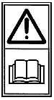 | "Read operator's manual"
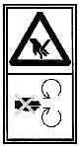 | “Danger - Rotating blades. Keep hands and feet out of openings while  machine is running.”
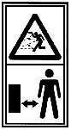 | "Keep bystanders away”
 | "Wear eye and hearing protection
 | "Do not use as a step"
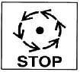 | Wait until all machine components had completely stopped before touching them
 | Do not expose to rain
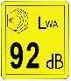 | Sound power level  92dB(A) according to directive 2000/14/EC
P40 | Intermittently operation mode, each cycle includes 40s at rated power input and 60s at no load.
 | The product complies with the applicable European directives and an evaluation method of conformity for these directives was done.
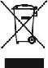 | Selective collection of electrical and electronic equipment waste.  Electrical products should not be disposed of with household products. According to the European Directive 2012/19/UE for electrical and electronic equipment waste and its implementation in national law, used electrical products should be collected separately and disposed of at collection points provided for this purpose. Consult with your local authorities or your dealer for advice on recycling.

3. Machine overview
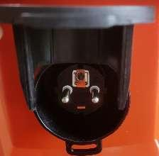
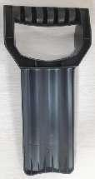
3
16
2

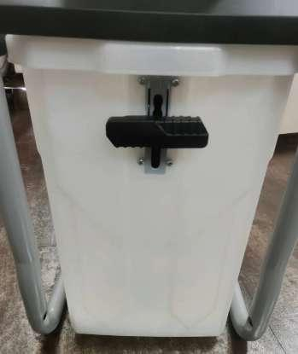
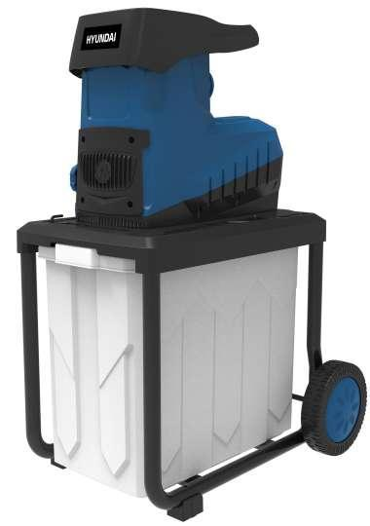
5
8
9
7
1
10
6
4
12
13
11

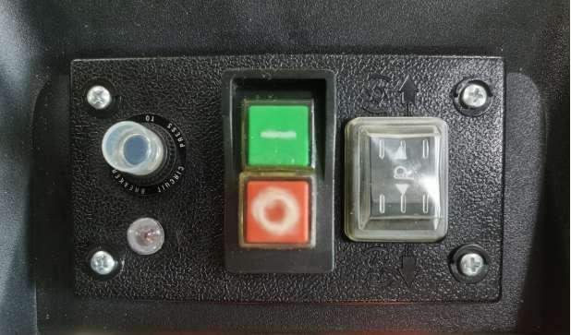
14
15

Counter blade knob

Carrying handle

Plug

Shredder unit/chassis

Collect container

Safety switch pusher

Base frame

Wheel

Wheel cover

Support foot

Circuit breaker / reset button

Power On switch

Direction switch

Overload warning light

Power Off switch

Push plate

4. Technical data
Rated voltage | 230-240V, 50Hz
Rated input power | 2800W S6 (P40)
Max. branch diameter | 4.7 cm
Capacity of collect container | 60 L
Protection against electric shock | Class I
Protection class | IPX4
weight | 26.7kg
Sound pression level | L_{pA} =75,7 dB(A)
uncertainty | K_{PA}=3dB(A)
Sound power level measured | 88,4dB(A)
uncertainty | K_{WA}=3 dB(A)
Sound power level guaranteed | 92 dB(A)

5.Assembling
- Open the package and remove the machine from package. Pull out the collect container and take out the main part of the machine and accessories
- Mount wheel shaft as below pictures shown.
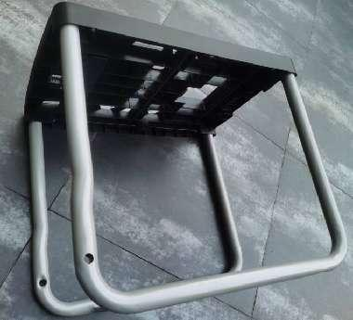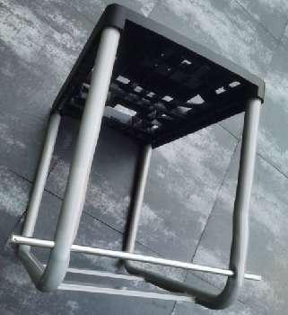
- Mount wheel and wheel cover as below pictures shown.
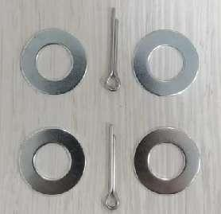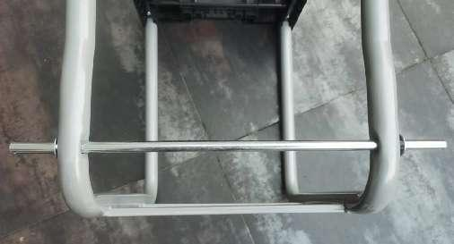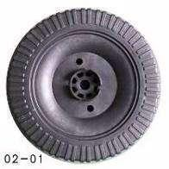
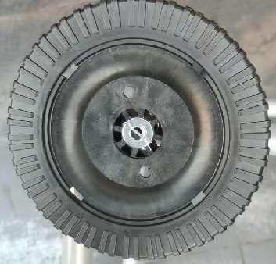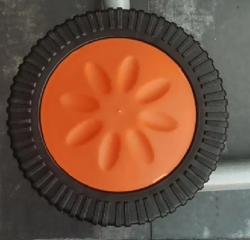
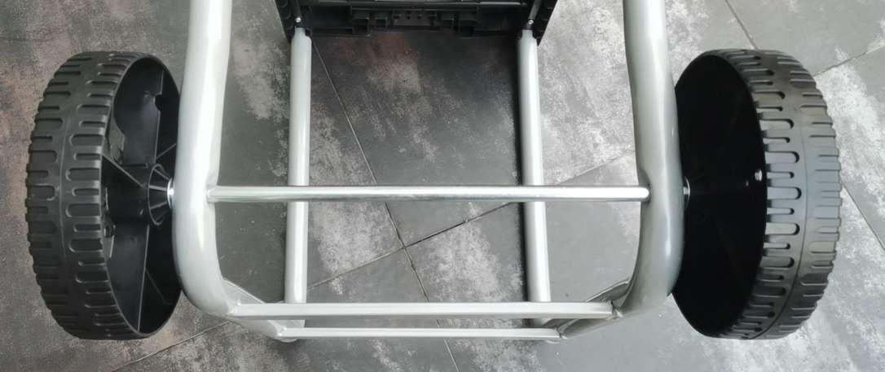
- Mount the support feet as below pictures shown.
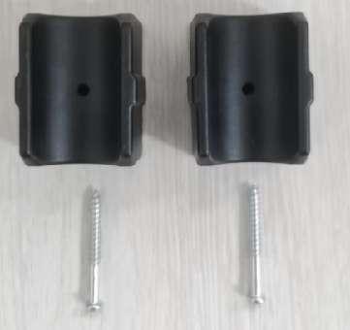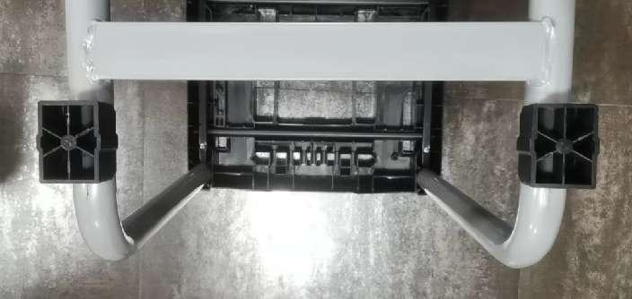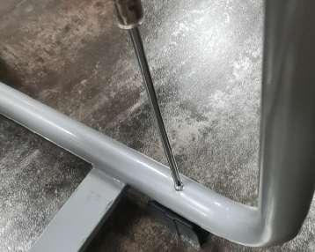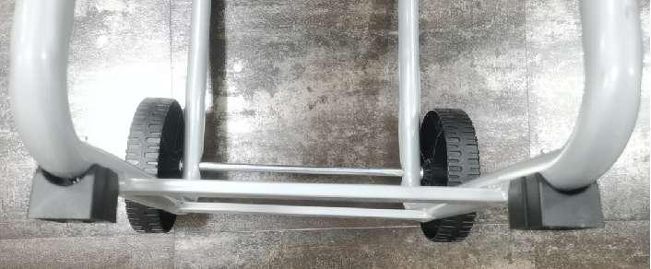

- Mount Shredder unit/chassis as below pictures shown.
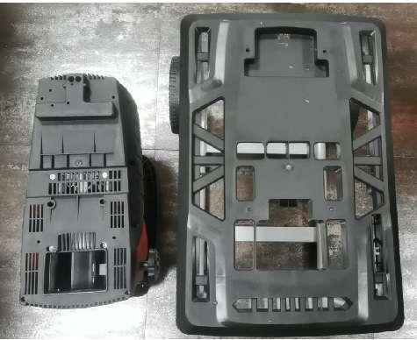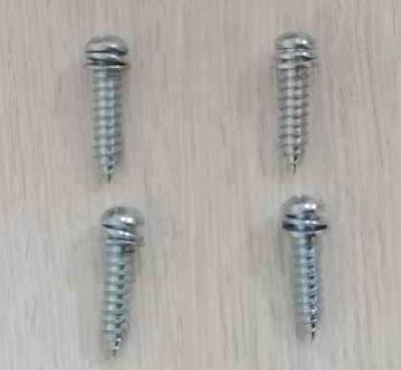
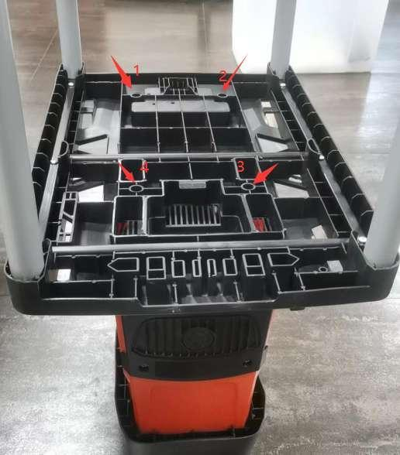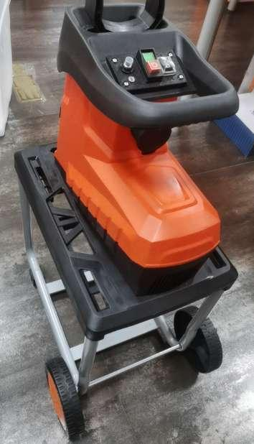
- Mount collect container as below pictures shown.
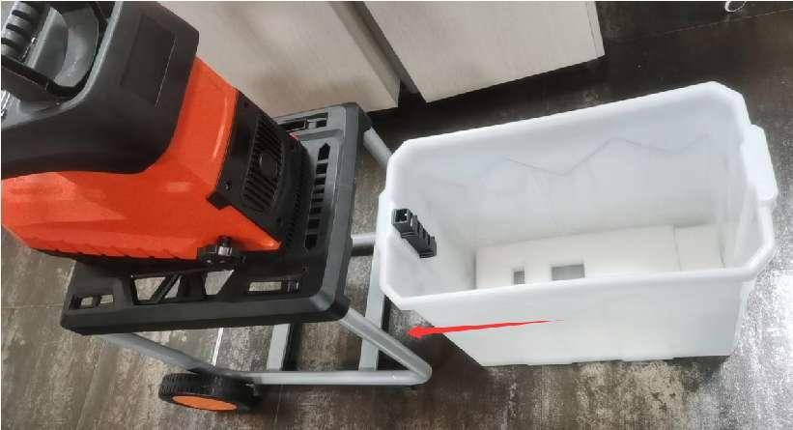
- Interlock switch pusher.
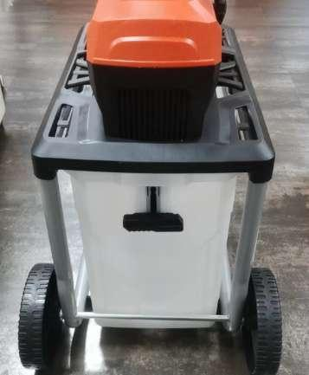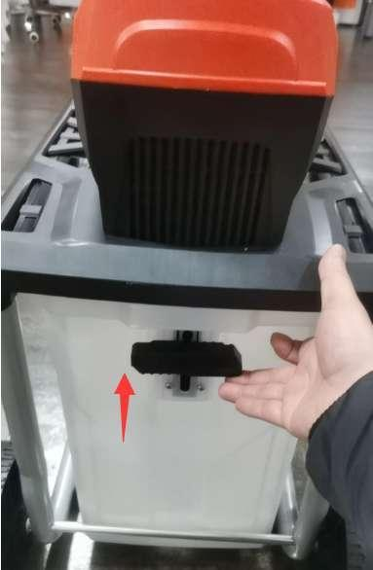

6. Operating instruction
6.1 Intended use
- The product is intended for outdoor domestic use in private gardens.
- The product is designed to shred garden debris such as clippings and small twigs within the limits of its characteristics (smaller than 45mm in diameter).
- It is not to be used for any other purpose outside of the described scope in this manual.
- It is recommended to use the product only on dry surfaces, do NOT operate on damp or wet working area.
- Do not use the machine for unsuitable purposes (for ex. for shredding other materials such as plastic, paper; metal…)
- The tool is not intended for artisanal, commercial, professional or industrial use
6.2 BEFORE any operation:
- Always visually inspect that the product does not show signs of use or damage. Replace any used or damaged part.
- Check that the screws, bolts and nuts are well tightened. Tighten firmly the screws, bolts and nuts when needed.
- Ensure that the collection container is properly and securely installed.
- Ensure that the machine is only connected to conventional sockets with a 230-240V alternating current supply.
- Only use extension cables, if they are really necessary, intended for outdoor use and approved.
- The use of extension cables may cause a drop in voltage, which will result in the machine not performing to its peak or the motor overheating.
- Look into the feeding chamber to make sure it is empty. Do NOT start machine before clearing any material still present in the feeding chamber.
6.3 DURING operation
- Keep proper balance and footing at all times. Do not over reach. Never stand at a higher level than the base of the machine, when feeding material into it.
- Always keep your fingers and hands away from the feeding chamber. Use the push stick to push in the material.
- -When feeding material into the machine be extremely careful that pieces of metal, rocks, glass bottles, cans or other foreign objects are not included.
- If the cutting mechanism strikes any foreign objects or if the machine should start making any unusual noise or vibration, switch off the machine and allow it to come to a complete stop, disconnect the plug from the power source, and take the following steps:
- Inspect the machine for damage.
- Check for and tighten any loose parts.
- Have any damaged parts replaced or repaired by an authorized service center with original parts.
- Always stand clear of the discharge zone when operating this machine. Do not allow processed material to build up in the discharge zone; this may prevent proper discharge and can result kickback of material through the feed intake opening. Empty the collection box regularly.
- Do not transport this machine while the power source is running.
- Switch off the machine and disconnect the plug from its power source whenever you leave the work area.
- Do not tilt the machine while in operation.
- Motor should be kept clean of debris and other accumulations.
6.4 To switch ON and OFF
1) Green button"I" , power on switch(12): press to start the shredder
2) Red button"O" power off switch(15): press to stop the shredder
Note: the machine is equipped with a safety switch to prevent it from being switched on again accidentally after a power failure.

6.5 Direction switch((13)
- Button "O" up direction: press the button "O" up direction part to make it run, shredding the branch .
- Button "O" down direction: press the button "O" down direction part to make it run in the reverse position, pulling out the branch.
- Once the button located on middle position, the machine stop working.

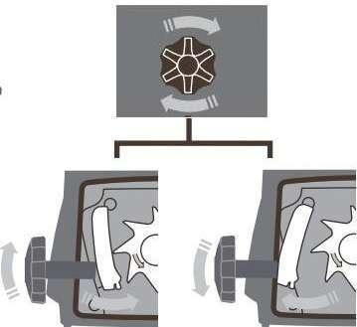
6.6 shredder start-up
1) Connecting the power
2) Press button "I"
3) Press green button"I"
4) Put the materials
6.7 when the dust bin is full:
1) press red button"O"
2) pull out the key of the interlock switch
3) pull out the dust bin
6.8 Adjusting the counter plate
To obtain an optimum shredding result and prevent damage to the blade, the counter plate must be adjusted at regular intervals.
The counter plate must also be adjusted when so called interlinkage occurs.
- Turn counter blade knob (1) clockwise until a slight friction noise can be heard and fine aluminum chips fall from the ejector chute for a short period of time.
- Then, the materials to be shredded should be fully cut again.

6.9 Tips for shredding:
Depending on the type, age and dryness of the wood, branches will be more or less easily shredded.
The best results are obtained when fresh branches are shredded shortly after being cut.
It is recommended to shred soft garden waste in small quantity, especially when the waste is wet. You can
avoid blockage by performing periodic shredding sessions.

7. MAINTENANCE AND STORAGE
WARNING!
Before any intervention on product, ensure that product is disconnected from its power source.
machine after each use and before storage. Any breach or default of adequate maintenance reduces the life of the machine and increases the risk of breakdowns and accidents.
To preserve the security system throughout the life of the machine, it is important to perform maintenance and proper cleaning, DO NOT use non-compliant replacement parts and do NOT dismantle yourself the machine or change the security features.
6.1- After using the machine
1) Empty the collection box.
2) Check the machine (feeding inlet and chute) and remove material residue.
6.2- Cleaning
Clean plastic parts with a soft and clean cloth
Do not use aggressive cleansers (solvents or abrasive cleansers), or an abrasive sponge.
Do not use any caustic to clean the plastic parts.
Do not put or immerse machine in water or any other liquid, and ensure that no water gets inside the machine.
Do not clean the machine with running water or high pressure.
6.3- Storage
Clean product and empty the collection box.
Store product, instructions manual and accessories in its original packaging.
Product must be stored in a clean, dry location. Always lock up product and keep out of reach of children.
Do not store product in temperatures lower than 0ºC (32ºF)
Do not place or store any object on top of the product.
6.4- Disposal
- Debris & remnants: do not throw with household rubbish or in the environment. Dispose of any debris and remnants in rubbish collection centres or seek advice from your local municipality.
- Machine: do not dispose with household garbage. Do not throw into the environment.
- Dispose of the product in a collection centre for waste of electrical and electronic equipment, or a waste drop-off centre; or seek advice from your local municipality.
- Proceed with disposal of remnants, machine, accessories and packaging according to local regulations regarding the protection of the environment.

8. EC declaration of conformity


BUILDER SAS
ZI, 32 rue Aristide Bergès – 31270 Cugnaux - France
Declares that the machinery designated below:
Silent shredder
HBVES2801
Serial number: 20240205476-20240205675
Complies with the provisions of the Directive “machinery” 2006/42/EC and national laws transposing it:
Also complies with the following European directives:
EMC Directive 2014/30/EU
ROHS Directive 2011/65/EU+2015/863/EU
Noise directive 2004/14/EC and 2005/88/EC
Sound power level - measured: 88.4 dB(A) K = 3 dB(A)
Guaranteed: 92 dB(A)
Also complies with European standards, with national standards and the following technical provisions:
EN 60335-1:2012 + A11:2014 + A13:2017 + A1:2019 + A14:2019 +A2:2019 + A15:2021
EN 50434: 2014
EN IEC 55014-1: 2021
EN IEC 55014-2: 2021
EN IEC 61000-3-2: 2019+A1:2021
EN 61000-3-3: 2013+A2:2021

Responsible for the technical file: M. Olivier Patriarca

Cugnaux, on 02/01/2024

Philippe MARIE / PDG
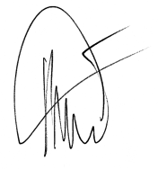

9. WARRANTY
The manufacturer guarantees the product against defects in material and workmanship for a period of 2 years from the date of the original purchase. It can be extended by one year if the user subscribes to website of myswap. The warranty only applies if the product is for household use. The warranty does not cover breakdowns due to normal wear and tear.
The manufacturer agrees to replace parts identified as defective by the designated distributor. The manufacturer does not accept responsibility for the replacement of the machine, in whole or in part, and/or ensuing damage.

The warranty does not cover breakdowns due to:
- insufficient maintenance.
- abnormal assembly, adjustment or operations of the product.
- parts subject to normal wear and tear.

The warranty does not extend to:
- shipping and packaging costs.
- using the tool for a purpose other than that for which it was designed.
- the use and maintenance of the machine done in a manner not described in the user manual.

Due to our policy of continuous product improvement, we reserve the right to alter or change specifications without notice. Consequently, the product may be different from the information contained therein, but a modification will be undertaken without notice if it is recognized as an improvement of the preceding characteristic.
READ THE MANUAL CAREFULLY BEFORE USING THE MACHINE.
When ordering spare parts, please indicate the part number or code, you can find this in the spare parts list in this manual. Keep the purchase receipt; without it, the warranty is invalid. To help you with your product, we invite you to contact us by phone or via our website:
- +33 (0)9.70.75.30.30
- https://services.swap-europe.com/contact

You must create a "ticket" via the web platform.
- Register or create your account.
- Indicate the reference of the tool.
- Choose the subject of your request.

- Describe your problem.
- Attach these files: invoice or sales receipt, photo of the identification plate (serial number), photo of the part you need (for example: pins on the transformer plug which are broken).

10. PRODUCT FAILURE
WHAT TO DO IF MY MACHINE BREAKS DOWN?
If you bought your product in a store:
- Make sure that your machine is complete with all accessories supplied, and clean! If this is not the case, the repairer will refuse the machine.
- Go to the store with the complete machine and with the receipt or invoice.
If you bought your product on a website:
- Make sure that your machine is complete with all accessories supplied, and clean! If this is not the case, the repairer will refuse the machine.
- Create a SWAP-Europe service ticket on the site: https://services.swap-europe.com When making the request on SWAP-Europe, you must attach the invoice and the photo of the nameplate (serial number).
Contact the repair station to make sure it is available before dropping off the machine.
Go to the repair station with the complete machine packed, accompanied by the purchase invoice and the station support sheet downloadable after the service request is completed on the SWAP-Europe site

Please keep your original packaging to allow for after-sales service returns or pack your machine with a similar cardboard box of the same dimensions.
For any question concerning our after-sales service you can make a request on our website https://services.swap-europe.com
Our hotline remains available at +33 (9) 70 75 30 30.

11. WARRANTY EXCLUSIONS
THE WARRANTY DOES NOT COVER:
- Start-up and setting up of the product.
- Damage resulting from normal wear and tear of the product.
- Damage resulting from improper use of the product.
- Damage resulting from assembly or start-up not in accordance with the user manual.
- Periodic and standard maintenance events.
- Actions of modification and dismantling that directly void the warranty.
- Products whose original authentication marking (brand, serial number) has been degraded, altered or withdrawn.
- Replacement of consumables.
- The use of non-original parts.
- Breakage of parts following impacts or projections.
- Accessories breakdowns.
- Defects and their consequences linked to any external cause.
- Loss of components and loss due to insufficient screwing.
- Cutting components and any damage related to the loosening of parts.
- Overload or overheating.
- Poor power supply quality: faulty voltage, voltage error, etc.
- Damages resulting from the deprivation of enjoyment of the product during the time necessary for repairs and more generally the costs related to the immobilization of the product.
- The costs of a second opinion established by a third party following an estimate by a SWAP-Europe repair station
- The use of a product which would show a defect or a breakage which was not the subject of an immediate report and/or repair with the services of SWAP-Europe.
- Deterioration linked to transport and storage*.

* In accordance with transport legislation, damage related to transport must be declared to carriers within 48 hours maximum after observation by registered letter with acknowledgement of receipt.
This document is a supplement to your notice, a non-exhaustive list.
Attention: all orders must be checked in the presence of the delivery person. In case of refusal by the delivery person, it you must simply refuse the delivery and notify your refusal.
Reminder: the reserves do not exclude the notification by registered letter with acknowledgement within 72 hours.
Information:
Thermal devices must be wintered each season (service available on the SWAP-Europe site). Batteries must be charged before being stored.



